LAB SKILL 1
NAME: LEE XUAN HUI
MATRIC NO.:A24DW0423

INSTRUCTIONS
Answer all questions. Screenshot your coding and output and paste inside this word answer template.

QUESTION 1
Write a C++ program to display multiple variables.
Declaration:
int a = 125;
int b = 12345;
long ax = 1234567890;
short s = 4043;
float x = 2.13459;
double dx = 1.1415927;
char c = 'W';
Variables:
- a + c
- x + c
- dx + x
- a + x
- s + b
- ax + b
- s + c
- ax + c

CODING
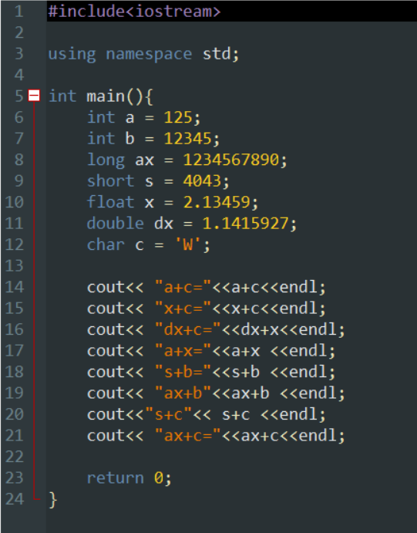
OUTPUT
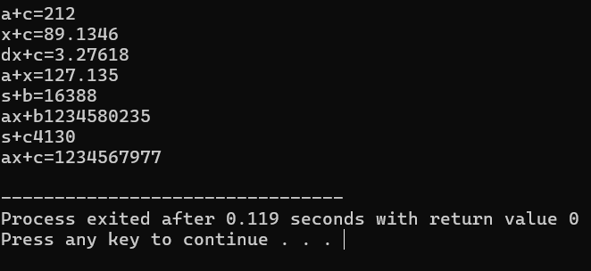

QUESTION 2
Write a C++ program that accepts two integers from the user and calculate the sum of the two integers.

CODING
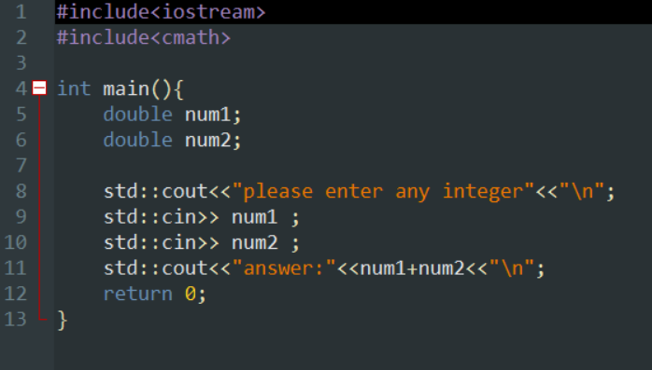
OUTPUT
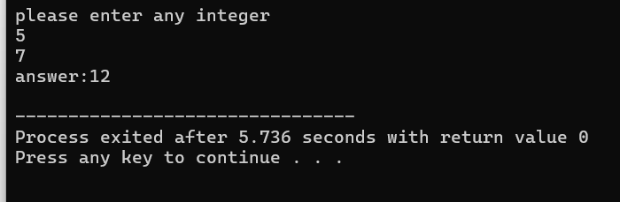

QUESTION 3
Write a C++ program that accepts an employee's ID (string, e.g.: PS0750), total worked hours of a month (number of total hours work per month, e.g.: 176 hours) and the salary amount he received per hour (salary per hour, e.g.: RM 6.50). Print the employee's ID and total salary (with two decimal places) of a particular month.
CODING
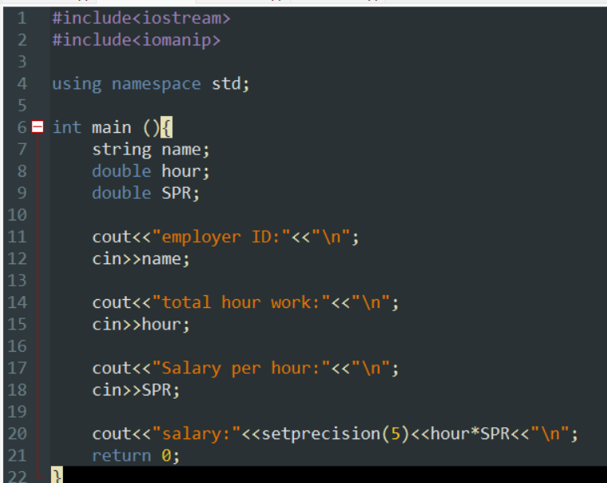
OUTPUT
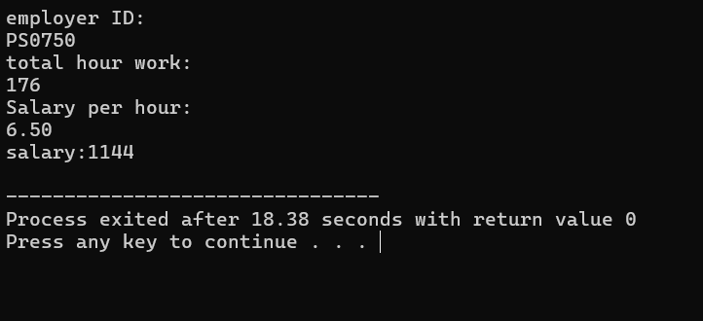

QUESTION 4
Write a C++ program to print a big 'CS'.
Expected Output:
####### #######
## ## ## ##
## ##
## ###
## ####
## ###
## ##
## ## ## ##
####### #######

CODING
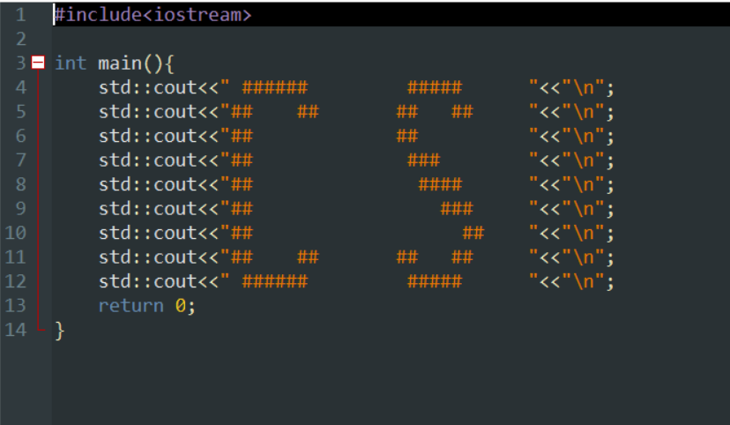
OUTPUT
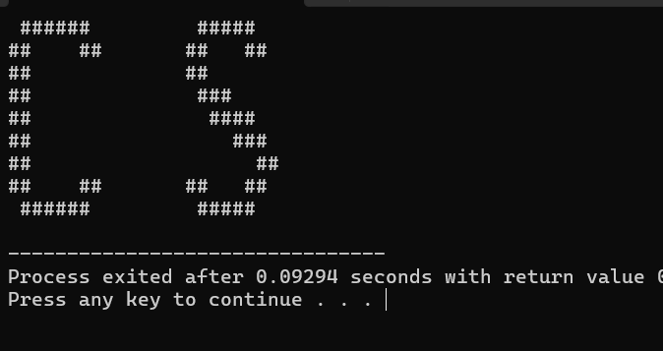QUESTION 5
Write a C++ program that accepts two integers from the user and calculate the product of the two integers.

CODING
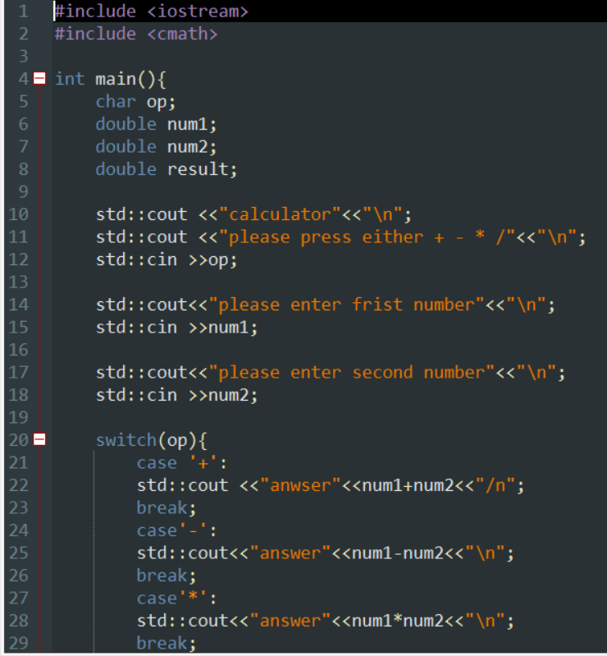
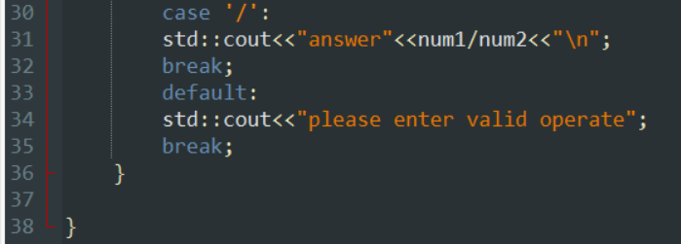

OUTPUT
